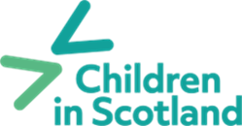
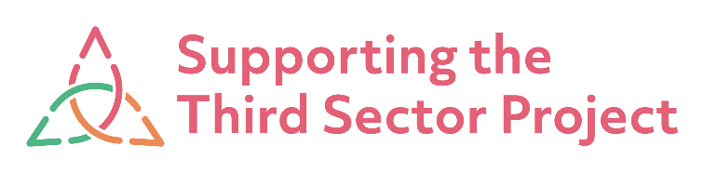

Purpose of Resource:

This resource is a proposal template that can be used by Third Sector Interfaces, Children’s Services Planning Partnerships and equivalent to begin conversations around the possible use of the ‘How Good is our Third Sector Participation in Children’s Service Planning?’ Self-evaluation tool.

The purpose of this template is to provide context surrounding the self-evaluation tool with relevant links, while providing an idea of what implementing the tool could look like. This template can and should be adapted to the context of the locality.

[Above to be deleted]

Implementing the ‘How Good is our Third Sector Participation in Children’s Service Planning?’ Self-evaluation tool

The ‘How Good is our Third Sector Participation in Children’s Service Planning?’ Self-evaluation tool supports third sector and statutory partners to work collaboratively to consider third sector participation in children's services planning using a self-evaluation approach.

This proposal provides context surrounding what the tool is and breaks down what implementation of the tool could look like based on the previous pilot and early adopters work.

- What is the ‘How Good is Our Third Sector Participation in Children’s Services Planning?’ Self-evaluation Tool?
This self-evaluation tool forms part of a developing suite of resources aimed at supporting partners across Scotland to work collectively to improve outcomes for children, young people and families, and has been informed by feedback from a pilot phase.
It was created in response to an identified need to strengthen the role of the third sector within Children’s Services Planning approaches across Scotland and aims to provide Children’s Services Planning Partnerships (CSPPs) with a structured approach to local discussions which considers different aspects of third sector participation across key strategic tasks in development, delivery, and reporting on Children’s Services Plans.
Click here to access the ‘How Good is Our Third Sector Participation in Children’s Services Planning?’ Self-evaluation Tool.
Purpose and use of the tool
Self-evaluation is an important feature of partnership working for supporting improved standards and quality of service delivery, as well as reflecting on the effectiveness of collaborative strategic planning and decision-making. The use of quality indicators helps provide a structured approach to evaluating ‘where are we now?’ and ‘where and how might we improve things further?’
The HGIO Self-evaluation tool is not designed to be used as a one-off activity, but instead CSPPs are encouraged to draw on relevant sections at different points across their planning cycle in the way that makes most sense to local needs. Partners should feel free to use the tool flexibly and can adapt questions to suit the CSPP’s individual circumstances and needs.
Area of Focus:
The HGIO Self-evaluation Tool is split into three areas of focus to help identify priority areas for self-evaluation. These closely link with key tasks and duties set out within Children’s Services Planning legislation (Part 3) and support statutory guidance.

The STTS Project team previously created a video resource for our early adopters of the tool, which provides an introduction to the tool and self-evaluation.

You can access the video here.
- What could implementation of the tool look like?

The tool requires ongoing input from the Children’s Services Strategic Lead, a representative from statutory services within the Children’s Service Planning Partnership or equivalent, and a representative from the local Third Sector Interface. This would make up a project team which would be responsible for moving the work forward and collaboratively identify an area of focus within the tool to explore through this targeted work.

The approach involves engaging with the local third sector and relevant statutory partners and will provide an opportunity to assess the participation of the third sector in children’s services planning. This can be achieved through facilitating engagement sessions that bring the third sector and statutory sector together to consider challenge questions and examples of highly effective practice to assess collaboratively how the systems surrounding Children’s Services Planning are currently performing.

This feedback would be collected and analysed by the core planning group implementing this piece of work with the aim of producing actions and improvement plan which would be shared with participating stakeholders. The tool also overs the option of a rating system which is optional.

Children in Scotland published a report that highlights the learning from the early adopter sites which Children in Scotland worked with in 2024 – 2025. This report also goes into detail of the processes and provides examples of how Aberdeenshire, Dumfries and Galloway and Glasgow approached the work.

You can access the Learning Report here.

A step-by-step guide has also been created from the learning of early adopter sites which breaks down the main steps taken to implement the tool.
You can access the step-by-step guide here.
Implementing the HGIO Self-Evaluation Tool in [Locality]
[insert in here how why and how it would be important to take this piece of work forward in their context.]
Contact us
If you have any questions regarding any of the above, a member of the STTS team would be happy to answer any questions. You can contact us via STTSProject@childreninscotland.org.uk
Who is Children in Scotland?
Children in Scotland is a national children’s charity rooted in children’s rights and working to improve children's lives.
Children in Scotland offer a broad, balanced, and independent voice by bringing together a network of people working with and for children, alongside children and young people themselves. Children in Scotland create solutions, provide support, and develop positive change across all areas affecting children in Scotland by listening, gathering evidence, and applying and sharing learning, while always working to uphold children’s rights.
Children in Scotland provide trusted support on issues as diverse as the people they work with and the varied lives of children and families in Scotland
What is the Supporting the Third Sector (STTS) Project?
The STTS Project provides support to third sector interfaces (TSIs) and the wider third sector to play a meaningful and influential role in national planning and decision-making to improve outcomes for children, young people, and families. The STTS Project is funded by the Scottish Government and hosted by Children in Scotland.
Click here to access more information about the STTS Project.

STTS Project, “Self-evaluation tool: How good is our third sector participation in Children’s Services Planning?” <https://childreninscotland.org.uk/wp-content/uploads/2024/01/STTSP_HGIO-tool-Final.pdf>
ibid.

