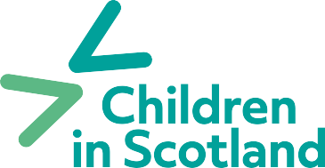

**Membership application form 2024**

|  |  |
| --- | --- |
| **Name:** |  |
| **Position:** |  |
| **Organisation:**  (Leave blank if joining as an individual) |  |
| **Address:** |  |
| **Postcode:** |  |
| **Tel:** |  |
| **Email:** |  |
| **Website:** |  |
| **Membership Category:** |  |
| **Please confirm Annual Income bracket:** (Required, unless for an  individual membership) | **Income < £50,000**  **£50,000 to £250,000**  **£250,000 to £1m**  **£1m to £2m**  **Over £2m** |
| **Please provide a description of your organisation or if an individual, your interests/ why you have joined:** |  |

|  |  |  |
| --- | --- | --- |
| **Where did you hear about Children in Scotland?** |  | |
| **Please provide the name and address of the person who will receive the hard copy of our bi-annual member publication Insight** (if different from above) |  | |
| **Please confirm you and your organisation agree with Children in Scotland’s vision and values** (found [**here**](https://www.childreninscotland.org.uk/about-us/our-priorities))  **Yes**  **No** | | |
| **I consent to Children in Scotland holding my information for the purposes of membership administration and communications**  **Yes**  **No**  *Please refer to our* [***privacy policy***](https://childreninscotland.org.uk/privacy-policy/)*for information on how we handle your data and how you can exercise your rights in relation to the personal data we hold for you* | | |
| **Are there staff members in your wider team that would be interested in receiving our monthly member newsletter which includes insights from the sector and information on opportunities for members?** *Provide additional names and email addresses from your organisation below and we will add them to our member mailing list. Please obtain their consent before providing email addresses.* | | |
| **Signature:** | | **Date:** |

Please return completed forms to **Tracy Hope,**

Senior Business Development Officer

Email: [thope@childreninscotland.org.uk](mailto:thope@childreninscotland.org.uk)