Conscious Awareness
Unconscious Process
 | 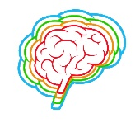  Brain  Facts | Body  Sensations | Heart  Feelings | Mind  Thoughts
Recognise the child’s communication
What is your initial response to the story?

Observe
How are you processing he story?

Acknowledge and Accept What is happening for you.
What might you avoid thinking about?
Responding or Reacting?
How would you normally respond?
Can you choose another way?

Context
In the card you have picked is there anything in the image that resonates?

How do you normally work?

What might you change?

Reflections on the child’s view of their trauma

