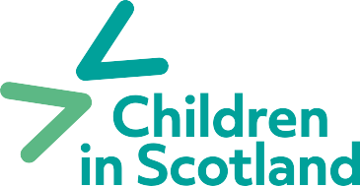

Membership application form 2024

Name:
Position:
Organisation:
(Leave blank if joining as an individual)
Address:
Postcode:
Tel:
Email:
Website:
Membership Category:
Please confirm Annual Income bracket:  (Required, unless for an individual membership) | Income < £50,000  £50,000 to £250,000  £250,000 to £1m  £1m to £2m  Over £2m
Please provide a description of your organisation or if an individual, your interests/ why you have joined:

Where did you hear about Children in Scotland?
Please provide the name and address of the person who will receive the hard copy of our bi-annual member publication Insight (if different from above)
Please confirm you and your organisation agree with Children in Scotland’s vision and values (found here)
Yes
No
I consent to Children in Scotland holding my information for the purposes of membership administration and communications
Yes
No
I consent to Children in Scotland sending me email communications about: Children in Scotland News Update
Children in Scotland Learning & Events Children in Scotland Policy activity
The work of our services (Enquire; Reach; My Rights, My Say; Resolve:ASL)
Signature: |  | Date:

Please return completed forms to Tracy Hope,
Senior Business Development Officer Email: thope@childreninscotland.org.uk

