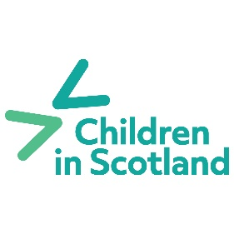
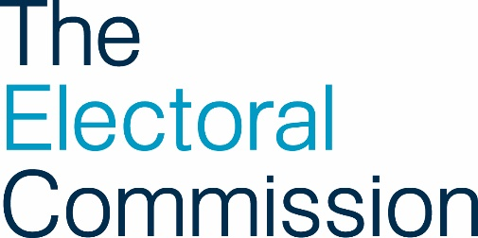

Youth Voice Network for Scotland Application Form
Thank you for your interest in this project! Please fill out the below and send to Arran Goodfellow: agoodfellow@childreninscotland.org.uk by 5pm on the 1^{st of} December 2023.
Name:

Date of birth:

Your contact details: | Email:  Phone:  (you can use a parent or carer’s contact details you don’t have an email address or phone number)
Town you live in:
Why do you want to be involved in this project?

You can answer these questions by typing them out on this form, or by another way that suits you such as a video, poem, audio recording or poster etc.

