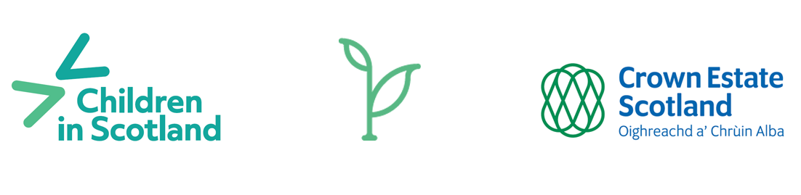

Crown Estate Scotland’s Children and Young People’s Forum
Application and Consent Form

Thank you for your interest in being part of Crown Estate Scotland’s new Children and Young People’s Forum. Please answer the questions below and email this form to Parisa on pshirazi@childreninscotland.org.uk by 5pm on Friday 22 September 2023.

Project name: Crown Estate Scotland’s Children and Young People’s Forum
Date: September 2023–September 2024
Your name:
Contact phone number:
Contact email address:
Address:

Date of birth:

Application questions:
Question 1:
Why would you like to be part of this group?

Question 2:
What would you like to learn from being part of this group?

Question 3:
If you were in charge of lots of land or seabed in Scotland for a day, what would you do and why?

CONSENT form

- TO TAKE PART IN A CHILDREN IN SCOTLAND PROJECT
- retain personal data provided on this form

Project name: Crown Estate Scotland’s Children and Young People’s Forum
Date: September 2023-September 2024
After you have read the information sheet, please indicate your response in the boxes below to show that you understand and would like to take part.
You also need to sign the ‘My Consent’ section at the end of this form. If you are under 16, we need your parent / carer to sign this consent form too.

You can update us if your information changes at any point.

Taking part
I have read and understood the information provided and would like to take part in the Crown Estate Scotland’s Children and Young People’s Forum. I understand that by taking part in this project, my views will be recorded and shared by Children in Scotland and Crown Estate Scotland in for example reports, websites and social media activity related to the project. | Yes / No

My name
I am happy to be identified by my first name as someone who takes part in the Crown Estate Scotland’s Children and Young People’s Forum. | Yes / No
Photographs and film
I am happy for photographs and film of me taken during the project to be used publicly by Children in Scotland and Crown Estate Scotland in for example reports, websites and social media. | Yes / No

Things we need to know
We want to make sure that you feel welcome and comfortable to take part. Please choose ‘yes’ or ‘no’ and give details where you can.

Do you have any allergies we should know about? Yes / No | Details:
Do you have any additional support needs you’d like us to know about (physical or learning disability, mental health issues, low confidence, specific communication needs, things you find it hard to talk about)?  Yes / No | Details:
Is there anything extra we can do to make sure that you can come along and participate fully? Yes / No | Details:
Are you taking any medication we should know about? Yes / No | Details:
Do you have any dietary requirements?  Yes / No | Details:
If you practice a religion, please tell us if there’s anything connected to taking part in the project that we should know about. | Details:

In the event of an emergency

Emergency contacts (please provide two)
Name 1:  Relationship to you:  Phone number: | Name 2:  Relationship to you:  Phone number:
In the event of emergency, do you agree that you can receive hospital or dental treatment, including an anesthetic?  Yes / No | Details:

Please sign the section below to give your consent

By completing and signing this form, you are consenting to Children in Scotland storing the data you have provided on this form. Children in Scotland will not share your personal details without asking your permission. We keep your data on file for no more than six months after the end of your involvement in the project. Crown Estate Scotland will not hold your personal contact details on file. For more information about our Privacy Policy, go to childreninscotland.org.uk/privacy-policy
My Consent | If you are under 16, your parent/carer must also give consent below:
Name: | Parent / carer name:
Signature: | Relationship to young person:
Date: | Signature:
 | Date:

If you have any questions about this form, please contact Parisa Shirazi at Children in Scotland on pshirazi@childreninscotland.org.uk

